## Skill-React

# React Hands-on Lab: Bloggerapp

# Code:

## Terminal Instructions:

## # 1. Create React app

## npx create-react-app bloggerapp

## # 2. Navigate into the app

## cd bloggerapp

## # 3. Start the development server

## npm start

## Code(App.js):

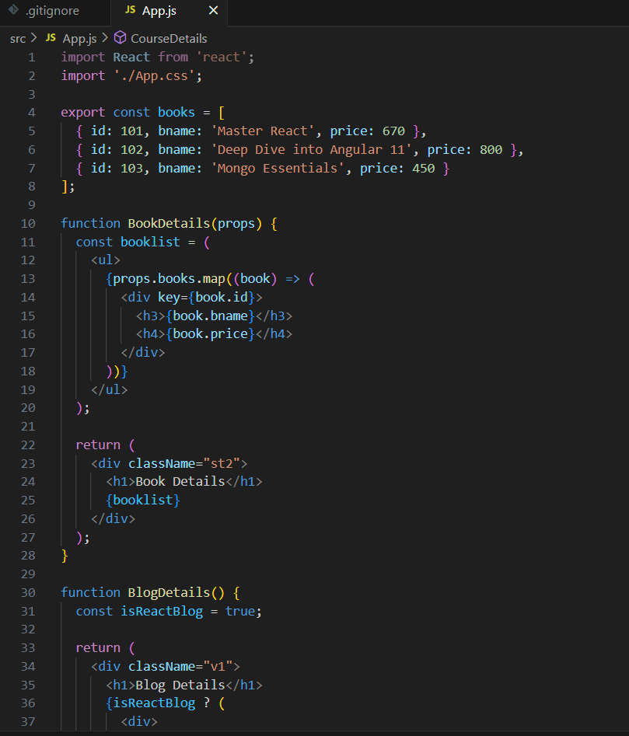

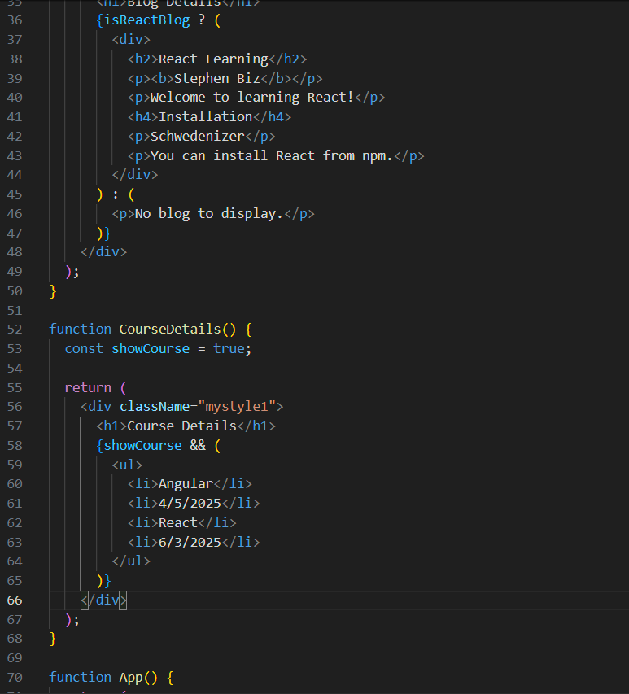

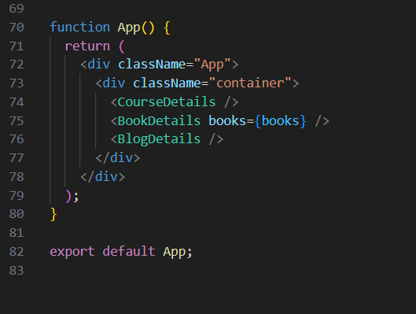

# Output:

